Knights of Columbus
Marion Council #4627
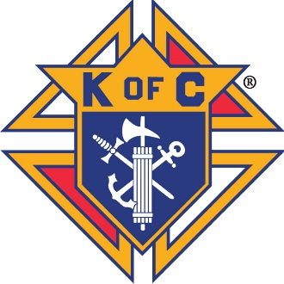

Dear Graduating Senior,

The Brush Council of the Knights of Columbus wishes to offer our congratulations on your upcoming high school graduation. A high school diploma represents twelve years of learning, sacrifice, and hard work and you are to be commended for your achievement.

This year the Knights of Columbus are offering up to 3 scholarships ranging from $250–$500 to be awarded to selected graduating seniors of St. Mary’s or St. John’s Parishes, who will be furthering their education in any field of study.

Applicants will be scored on academic achievement and extra-curricular participation. A greater scoring emphasis will be on character and need. The highest scoring emphasis will be placed on knowledge and interest in our Catholic faith.

Please complete and return the enclosed scholarship application to the address below by April 20, 2019. Qualified applicants will be invited to a brief, informal interview with a panel of three judges. The judges will score each of the applicants and determine the highest scoring applicant. Scholarship recipients will be promptly notified of the outcome.

Good luck in your pursuit of this scholarship opportunity and all your future endeavors.

Sincerely,

Your Knights of Columbus

Submit applications to:

Knights of Columbus
Marion Council #4627
340 Stanford St.
Brush, CO 80723
Knights of Columbus
Marion Council #4627

Scholarship Application

Name: _________________________________ Phone: ________________________

Address: ________________________________________________________________

Parents: ________________________________________________________

Grade Point Average: _____________

List Clubs and Extracurricular Activities: ______________________________________ ________________________________________________________________________________________________________________________________________________________________________________________________________________________________________________________________________________________________________________________________________________________________________

Areas of Interest: __________________________________________________________ ________________________________________________________________________________________________________________________________________________

Community Activities: ______________________________________________________ ________________________________________________________________________________________________________________________________________________________________________________________________________________________________________________________________________________________________________________________________________________________________________

Annual Gross Household Income:
(Circle the appropriate value)

- <$30,000
- $30,000 – $50,000
- $50,000 – $75,000
- $75,000 – $100,000
- >$100,000

Employment Experience: ___________________________________________________ ________________________________________________________________________________________________________________________________________________________________________________________________________________________________________________________________________________________________________________________________________________________________________
________________________________________________________________________________________________________________________________________________________________________________________________________________________________________________________________________________________________________________________________________________________________________

Education Plans

School: _________________________________________________________________

Field of Study: ___________________________________________________________

